Professor Tina Smilkstein

EE431 [ October 7, 2021]

Austin Ma

Key binding Ctrl+A selects all of the figures in the schematic

Key binding Ctrl+D deselects all of the figures in the schematic

The lower case f key allows us to zoom the schematic to fit on screen

1. 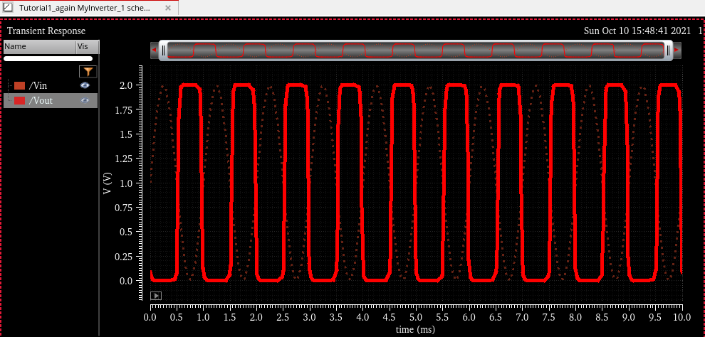
2. 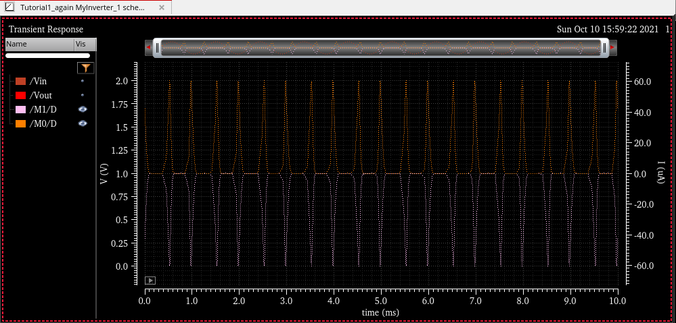

So 60uA seems to be the max current draw

1. 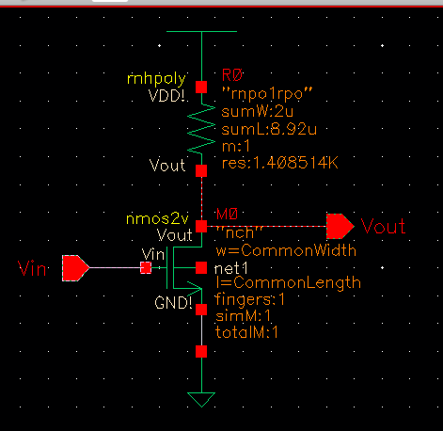

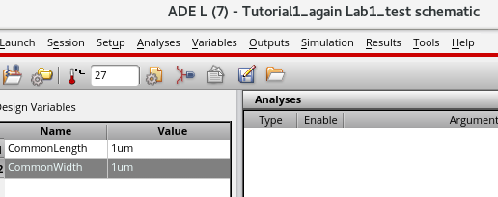

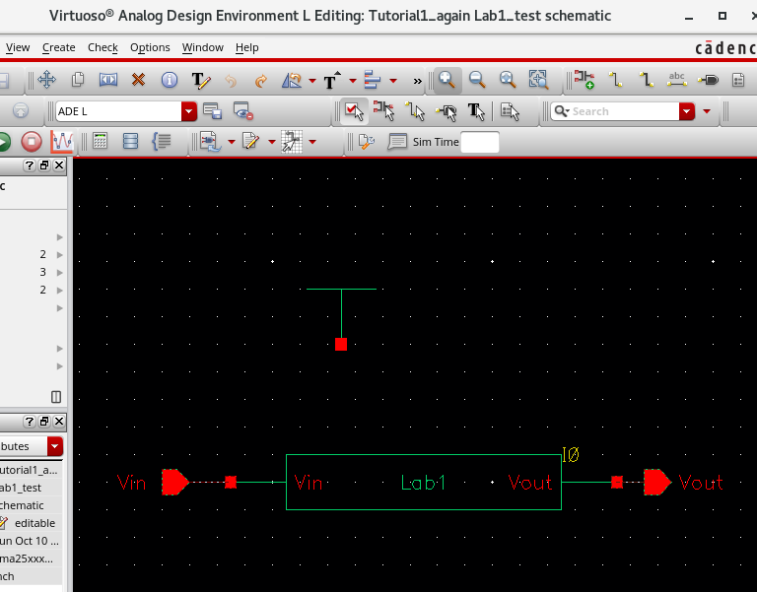

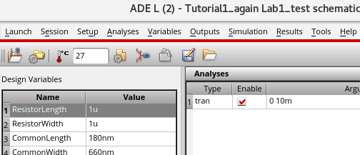

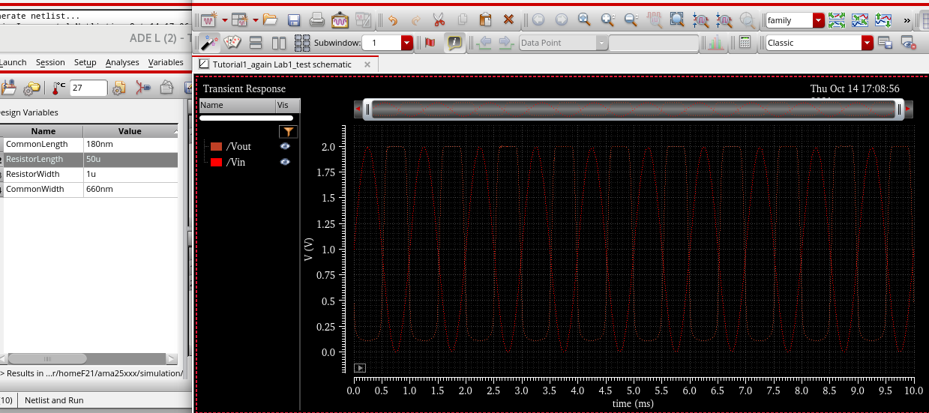

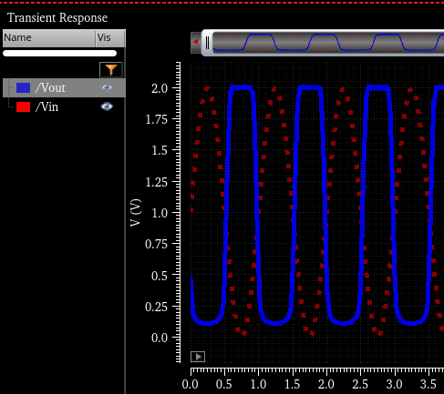

Why does the simulation take 1 minute to do sometimes and 2 seconds to do othertimes?